Unknown Indicators, Acids, and Buffers

If we knew what it was we were doing, it would not be called research, would it?

– Albert Einstein

In the following three experiments, you will design your own experiments. We will explain the general problem — the analysis of an unknown — and give you a brief introduction to any necessary theory. Working in a team of students, you will design and carry out every aspect of the experiment. You and your team will have to answer many seemingly mundane questions for yourself. How much solution should you make? What concentration should the solution be? What glassware should you use? You will also have to come up with your own strategy.

You will have a total of 4 lab periods to complete 3 experiments: the *pKa* of an unknown indicator, the identity of an unknown solid acid, and the composition of an unknown imidazole buffer. We strongly suggest that you do not try to leave early until your group has finished all of the experiments and analyzed all of your data. Do not fall behind, as you will not be given additional time. The suggested timeline is as follows:

Week 1: *pKa* of an Unknown Acid-Base Indicator

Week 2: *pKa* of an Unknown Acid-Base Indicator

Week 3: Identification of an Unknown Solid Acid

Week 4: Composition of an Unknown Buffer

I have one very important suggestion: Think before you act! The pre-laboratory questions for these experiments are designed to get you thinking along the right track. Because of time constraints, you must have a clear picture of what you are doing in your experiment before you start. Spending an extra 10 minutes discussing your plans with your group can save hours. Before you take your data, make sure that you know exactly how you will analyze your results. Otherwise, you might forget to make some vital measurements. Also, make sure to record all of your observations in your notebook.

Most importantly, have fun. This is what chemistry is all about.

— MAH

**The *pKa* of an Unknown Acid-Base Indicator**

Your group will be assigned a solution containing an unknown amount of an unknown acid-base indicator. In the following, you will design and carry out a series of experiments designed to first qualitatively and then quantitatively measure the *pKa* of this indicator dye, which is defined to be

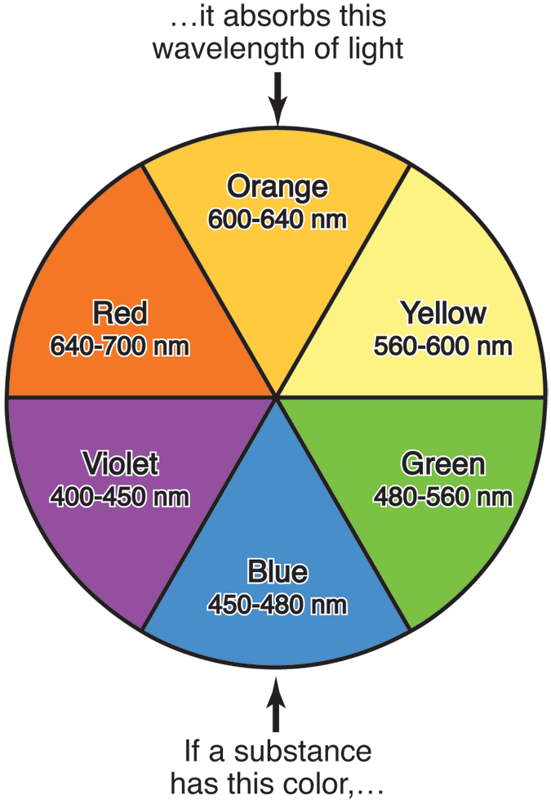

Fig. 1: A color wheel summarizes the relationship between the perceived color of a substance and the color of light that it absorbs, which is the complementary color. The approximate wavelengths of the colors are also listed.

 . (1)

This definition is in direct analogy to *p*H, which is defined to be

 . (2)

Each group will have access to *one p*H meter and *one* visible spectrometer. Because of this, it is important that you work efficiently when making your measurements. After your team decides on an experimental strategy, *everyone should be making measurements.* For this reason, it is important that you operate *as a team* in scheduling and sharing equipment. At the end of the experiment, you will share your results with your team members; however, part of your grade will be determined by whether you performed your fair share of the team’s experiments.

An indicator dye is just a weak acid (or base) that changes color when it loses (or gains) a proton. For the weak acid case, this process can be qualitatively described by the reaction

 (3)

For example, the popular indicator bromothymol blue is yellow at low *p*H (high [H+]), turning blue-green at *p*H ~ *pKa* ~ 7.0 before becoming dark blue at high *p*H (low [H+]). This behavior is shown in Fig. 21.7 in McQuarrie *et al*.

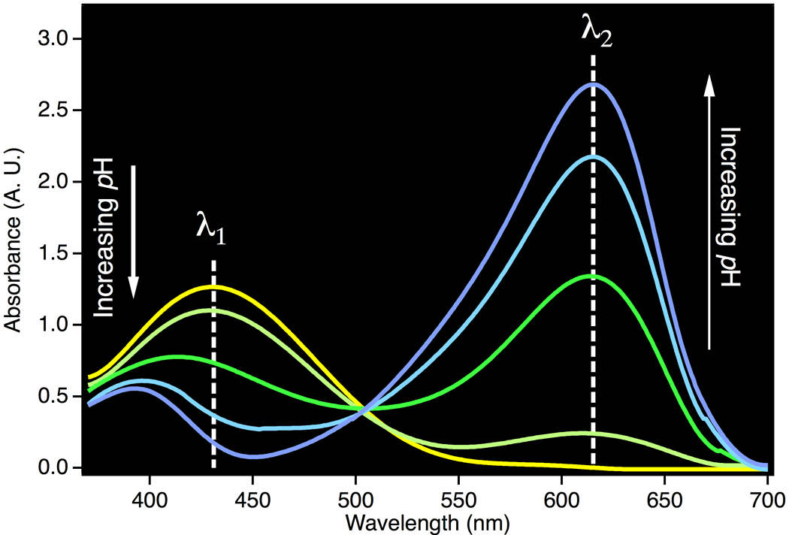

Fig. 2: The visible spectrum of bromothymol blue in solutions of varying *p*H, ranging from highly acidic (yellow) to highly basic (dark blue). The total concentration of bromothymol blue (*i.e.,* [H*In*] + [*In*–]) is the same in each spectrum.

The visible color of a solution can be quantified by measuring the colors of light that solution absorbs, or its *absorbance,* using a visible spectrometer. For example, if a solution appears yellow in white light (*i.e.* normal room light), the solution must be selectively *absorbing* non-yellow light. This implies that the solution is *absorbing* the complementary color of yellow, which is violet. On a visible spectrometer, this solution would be expected to have a maximum absorbance in the violet range, which corresponds to wavelengths of ~400-430 nm. Figure 1 summarizes the relationship between the color of light, its wavelength, and its complement.

Looking at Fig. 1, we can surmise that very basic solutions of bromothymol blue, which are dark blue, must be selectively absorb orange light. This corresponds to light with wavelengths in the range of ~600-640 nm.

Figure 2 shows the *visible spectrum* of a bromothymol blue in 5 different solutions which range from very acidic (yellow line) to very basic (blue line). The colors of the lines roughly correspond to the perceived color of the solutions. At the very lowest *p*H, the spectrum displays a single maximum at 431 nm, which corresponds to 1 in Eqn (1). As the *p*H of the solution increases, the maximum at 431 nm decreases in intensity, which indicates that the concentration of H*In*, the undissociated form of bromothymol blue, is decreasing. As this occurs, a new absorption band begins to increase at 615 nm, which corresponds to 2 in Eqn (1). Light at this wavelength is absorbed by *In–*, the dissociated form of bromothymol blue.

One aspect of Fig. 2 may be confusing: In basic solutions, some spectra show a small secondary maximum near 390 nm that is also attributed to the absorption of *In–*. Secondary maxima such as this are common in large molecules and can be ignored in this experiment.

Chemists use visible spectrometers to *quantify* color and to relate color to concentration. For example, the most basic solution in Fig. 2 has a maximum absorbance at 617 nm of 2.678. If this solution were diluted by a factor of two at constant *p*H, the absorbance at 617 nm (or at any wavelength) would decrease by a factor of two. The new absorbance would thus be 2.678/2 = 1.339. Because of this, the absorbance reading (*i.e.* the quantitative color) can be used to measure *relative concentrations* of colored solutions using

 , (4)

where *A1*() is the absorbance of a solution of some species at concentration *c1* at some wavelength , and *A2*() is the absorbance of the same species at a concentration *c*2 at the same wavelength .

Another example will help to illustrate the use of this equation. Suppose that a 0.10 M solution of yellow food coloring that has an absorbance of 0.378 at a wavelength of 445 nm. If you are given a second solution which has a measured absorbance of 0.0179 also at 445 nm, the concentration of the second solution must be:

 (5)

Up to this point, we have only considered light of one specific wavelength even though Fig. 2 shows that both H*In* and *In–* absorb at many different wavelengths. Which wavelengths should we use to measure the concentrations of H*In* or *In–*? Inspection of Fig. 2 reveals one *very bad wavelength:* 505 nm. Notice that all 5 solutions absorb almost the same amount of light at this wavelength. This is because both H*In* and *In–* absorb 505 nm light. If we want to quantify the amount of H*In*, we should use a wavelength where H*In* has a high absorbance, and *In–* has essentially no absorbance. Conversely, if we want to quantify the amount of *In–*, we should use a wavelength where *In–* has a high absorbance, and H*In* has essentially no absorbance.

One final point deserves mention: the importance of strong absorbance. Figure 2 suggests that any wavelength between 600-700 nm could be used to quantify *In–*, because H*In* does not absorb in this range. While technically true, this assumption neglects the effects of noise. By measuring the absorbance near the maximum wavelength, the effects of spectrometer noise will be minimized. As a result, the best wavelength for measuring [*In–*] is approximately 615 nm.

Objective

Measure the *pKa* of an unknown acid-base indicator first qualitatively, then quantitatively.

Available Equipment and Reagents

You may use the following items in Calvin to design your experiment:

Standardized Acid Solution: ~0.10 M HCl (Exact concentration reported by Calvin.)

Standardized Base Solution: ~0.10 M NaOH (Exact concentration reported by Calvin.)

Known Indicator Solution: Bromocresol_green

Unknown Indicator Solution: Assigned by TA.

*p*H meter

visible spectrophotometer

100 ml beakers

50 ml volumetric flasks

50 ml buret

20 ml pipette

10 and 25 ml graduate cylinder

You *may not use* the following items in Calvin for this experiment:

Solid acid

Buffer

Experimental Considerations

1. The indicators work best at a concentration of ~1 drop/50 ml. This is a relative concentration of 1.0 in Calvin. You will run into problems if your dyes are too concentrated or too dilute, just like in real life.

2. You will have no way of measuring the absolute concentration of your unknown indicator solution. You will, however, be able to make up solutions with identical total dye concentrations (*i.e.,* [H*In*] + [*In–*]) by adding the same number of drops of indicator to a constant volume of solution.

Experiments

1. Using only your eyes, the stock acid and base solutions, the *p*H meter, and any additional water that you may require (*i.e.,* no spectrometer!), estimate the *pKa* of your indicator dye.

2. Design and perform an experiment to find the best wavelengths for quantifying the relative amounts of the dissociated (*In–*) and undissociated (H*In*) states of your unknown indicator dye.

3. Design and perform an experiment to accurately measure the *pKa* of a your unknown indicator using the visible spectrometer. At each *p*H that you investigate, you should measure the absorbance of your solution at two wavelengths. Test this procedure on the bromocresol green solution, which has a *pKa* of 4.7.

Before making any measurements on your unknown indicator, you must test your procedure on bromocresol green and perform **all necessary *pKa* calculations** in your notebook. Your must have your numerical calculations on bromocresol green checked by your TA before proceeding with the unknown. Students who do not have their results checked will have 15 points deducted from their lab report grade.

4. Determine the *pKa* of your unknown indicator using the procedure developed above.

**We strongly suggest that you download your Calvin files to your computer in case one of your group mates deletes the file from Box.**

Safety Considerations

There are no safety considerations.

Waste Disposal

The experiment will not generate waste.

Laboratory Report

All lab reports must be written individually. Data that are recorded as a group should be attributed in the lab report to all members of the group. Data that are recorded by a specific group member and shared with the group must be explicitly attributed to the group member who did the work. All text, tables, and figures in your lab report should be prepared by you; copying these materials from another student or sharing your materials with another student is a violation of the Cornell Code of Academic Integrity.

Your report should have the usual cover sheet and should contain an abstract, an introduction, an experimental section, and a results and discussion section. In the abstract, you should mention the experimentally observed *pKa* for your dye as well as the wavelengths that you used to quantify the dissociated and undissociated forms of the dye. Your experimental section must contain a *complete* description of your experimental procedure. Any Chem 2080 student should be able to reproduce your experiment after reading your lab report. This section does not have to be long, but it does have to be complete. The results and discussion section should consist of two parts. First, you should prove that your experimental procedure works by presenting your analysis of bromocresol green. Following this, you should present your analysis of your unknown indicator. Discuss how and why you selected your analysis wavelengths. Please include a qualitative discussion of the possible sources of error in your experiment.

In lieu of notebook pages, please turn in a single file with all of the Calvin logs used in your final analysis.

The Identification of an Unknown Solid Acid

Your group will be assigned an unknown, monoprotic solid acid drawn from the list in Table 1. Your goal is to design and perform two titration experiments that will allow you to identify the acid from a list of known acids. You should base your identification on a measurement of the molar mass and the *pK*a of your unknown. Since you will be designing your own experiment, it is imperative that you test your procedures on a known solid acid. A supply of potassium hydrogen phthalate (KHP) will be made available for this purpose. KHP has a molar mass of 204.23 g/mol and a *pK*a of 5.408.

Your first titration experiment should be designed to measure the molar mass of your unknown acid, whereas the second experiment should be designed to measure the *pK*a of your acid. One of your experiments must be done with one of the known indicator dyes (*i.e.,* no *p*H meter). The other experiment must be done with a *p*H meter (*i.e.,* no indicator dye).

Since your experiments will be *quantitative,* you need to make sure that you use a quantified amount of acid. You will therefore have to decide how you are going to perform this quantification. Will you weigh out a precise amount of unknown acid for each experiment or will you make up a stock solution for many experiments? Remember that if you decide to make up a stock solution, you will need to use a volumetric flask. To transfer a precise amount of solution, you must use a pipette. (Graduated cylinders are only used for approximate measurements. Precise volume measurements can only be made with volumetric flasks, pipettes, or burets.)

The first question to ask is what experiments are you and your team going to perform? Once you decide on your experiments, split your team into two sub-teams and test the experiments on KHP. Make sure that your experiments give the correct answer for KHP *before* you start working with your unknown.

The second question to consider is the concentration of your solutions. The choice is entirely up to you, but there are some factors to consider:

• The stock HCl and NaOH solutions are approximately 0.10 M*.* Exact concentrations will be posted in the lab.

• Your buret holds 50.0 ml of solution and is labeled in 0.1 ml increments. You should make measurements to the nearest ~0.01 ml by interpolating by eye (see Fig. 12.14 in McQuarrie *et al.*). For accuracy, you should try to perform titrations that require a total of ~10–20 ml of added acid/base. A titration that requires 0.9 ml will be difficult to measure quantitatively, whereas a titration that requires 75 ml will be both wasteful and less accurate.

Since you know the molar mass of KHP, calculate the number of grams of KHP that you will need for your solution. Since you don’t know the molar mass of your unknown acid, your best bet is to use the same mass of unknown.

When you make your solutions, *do not* try to add exactly the amount of acid you calculated. Instead, weigh out approximately the correct amount of acid, then record the exact amount in your notebook. For example, if you are aiming for 0.5 g of KHP, an actual value 0.4893 g or 0.5217 g is fine. Also, some solid acids are more soluble than others. You may need to heat your solution gently to get the desired amount of acid into solution. It is *imperative* that all of the acid dissolves. Otherwise, your experimental results will be flawed.

Table : Properties of some solid acids.

When you perform a titration, do not try to fill your buret exactly to 0.00. Instead, record the starting volume (*e.g.,* 1.75 ml) and the final volume (*e.g.,* 27.85 ml), finding the total volume by difference (here*,* 26.10 ml).

Objective

Identify an unknown solid acid from two experiments, one using an acid-base indicator and one using a *p*H meter.

Available Equipment and Reagents

You may use the following items in Calvin to design your experiment:

Standardized acid solution: ~0.10 M HCl (Exact concentration reported by Calvin.)

Standardized base solution: ~0.10 M NaOH (Exact concentration reported by Calvin.)

Indicator solutions: Methyl_orange, Thymol_blue, and Phenolphthalein (See Fig. 21.7 in McQuarrie *et al*. for properties. See note in Unknown Indicator experiment about concentrations.)

Known solid acid: KHP

Unknown solid acid: Pure solid. Assigned by TA.

*p*H meter

visible spectrophotometer

100 ml beakers

50 ml volumetric flasks

50 ml buret

20 ml pipette

10 and 25 ml graduate cylinder

You *may not use* the following items in Calvin for this experiment:

Buffer

Experimental Considerations

1. Read Section 12-6 in McQuarrie *et al.* before you design your experimental protocol or come to lab.

2. One of your titration experiments, either to determine molar mass or *pK*a, must use the indicator dye, but not a *p*H meter. The other experiment must use a *p*H meter, but not an indicator dye.

3. Each titration must be performed *at least* 3 times for accuracy. This experiment will require at least 12 titrations: 3 for the molar mass determination of KHP, 3 for the *pK*a determination of KHP, 3 for the molar mass determination of the unknown acid, and 3 for the *pK*a determination of the unknown acid.

Experiments

*Note:* Everyone should *individually* perform at least one experiment to determine molar mass and one experiment to determine *pKa*. Everyone in the team should measure both the *pK*a and the molar mass of the unknown acid (but not necessarily of the known acid).

For accuracy, your team should make multiple measurements of both the *pK*a and the molar mass of your unknown. If all of the experiments are in good agreement, you will be able to average your results to reduce the effect of experimental error. If some of the experiments give anomalous results, you will need to consider your strategy carefully.

1. On the first day, your group should decide on an experimental strategy. (Before coming to lab, you should have already developed a plan yourself. The discussion among your teammates should be brief, as time is limited.) In designing your experiments, remember that one experiment *must* use a *p*H meter (no indicator dye), while the other *must* use a known indicator dye (no *p*H meter!)

2. Once you decide on a strategy, split your team into two groups and try your proposed experiments on KHP. Compare the results of these experiments to the *known* molar mass of KHP. If you cannot reproduce the known results, *rethink your strategy.* From these measurements, you will also get a rough idea of your experimental accuracy, which will be important in determining the identity of your unknown.

3. Once you have completed the KHP experiments, you will need to determine the molar mass and *pK*a of your unknown acid. Everyone in the group should make *at least one* determination of *pK*a and one determination of molar mass.

Safety Considerations

There are no safety considerations.

Waste Disposal

The experiment will not generate waste.

Laboratory Report

All lab reports must be written individually. Data that are recorded as a group should be attributed in the lab report to all members of the group. Data that are recorded by a specific group member and shared with the group must be explicitly attributed to the group member who did the work. All text, tables, and figures in your lab report should be prepared by you; copying these materials from another student or sharing your materials with another student is a violation of the Cornell Code of Academic Integrity.

Your report should have a cover sheet and should contain an abstract, an introduction, an experimental section, and a results and discussion section. In the abstract, you should mention the identity of your unknown and your percentage error in determining the *pKa* and the molar mass. Your experimental section must contain a *complete* description of your experimental procedure. Any Chem 2080 student should be able to reproduce your experiment after reading your lab report. This section does not have to be long, but it does have to be complete. The results and discussion section should consist of two parts. First, you should prove that your experimental procedure works by presenting your analysis of KHP. Following this, you should present the analysis of your unknown acid. Both analyses should include estimates of your experimental error (assuming that you correctly identified your unknown acid). Remember that the percentage error is defined to be

 . (1)

Please include a qualitative discussion of the possible sources of error in your experiment.

In lieu of notebook pages, please turn in a single file with all of the Calvin logs used in your final analysis.

**The Compositionof an Unknown Buffer**

Your group will be given a sample of a buffer containing only unknown quantities of imidazole (a weak base), imidazolium chloride, and water. Imidazole reacts in water in much the same way that ammonia does:

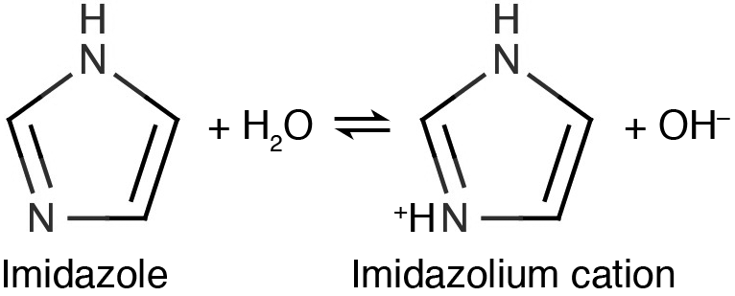 *pKb* = 7.05

Your goal is to design and perform an experiment to determine the molar concentration of imidazole and imidazolium chloride in this solution. You may use any equipment that you like; however, your team will again have only one *p*H meter. For this reason, you should carefully consider whether or not you actually want to perform a titration with the *p*H meter. There are a number of different ways of solving this problem, some requiring *p*H meters and others not. You should carefully consider both the ease *and the accuracy* of your chosen method.

Objective

Measure the concentrations of imidazole and imidazolium chloride in an unknown buffer solution.

Available Equipment and Reagents

You may use the following items in Calvin to design your experiment:

Standardized Acid Solution: ~0.10 M HCl (Exact concentration reported by Calvin.)

Standardized Base Solution: ~0.10 M NaOH (Exact concentration reported by Calvin.)

Indicator Solutions: Methyl_orange, Thymol_blue, and Phenolphthalein (See Fig. 21.7 in McQuarrie *et al*. for properties. See note in Unknown Indicator experiment about concentrations.)

Known Buffer Solution: ~0.05 M imidazole/imidazolium chloride solution (Exact concentration reported by Calvin.)

Unknown Buffer Solution: Assigned by TA.

*p*H meter

visible spectrophotometer

100 ml beakers

50 ml volumetric flasks

50 ml buret

20 ml pipette

10 and 25 ml graduate cylinder

You *may not use* the following items in Calvin for this experiment:

Solid acid

Experiments

You should design and perform experiments to measure the concentrations of both components of your unknown buffer. Before performing any experiments on your unknown, *you must test your procedure* on the known buffer solution.

Safety Considerations

There are no safety considerations.

Waste Disposal

The experiment will not generate waste.

Laboratory Report

All lab reports must be written individually. Data that are recorded as a group should be attributed in the lab report to all members of the group. Data that are recorded by a specific group member and shared with the group must be explicitly attributed to the group member who did the work. All text, tables, and figures in your lab report should be prepared by you; copying these materials from another student or sharing your materials with another student is a violation of the Cornell Code of Academic Integrity.

Your report should have a cover sheet and should contain an abstract, an introduction, an experimental section, and a results and discussion section. Your experimental section must contain a *complete* description of your experimental procedure. Any Chem 2080 student should be able to reproduce your experiment after reading your lab report. This section does not have to be long, but it must be complete. The results and discussion section should consist of two parts. First, you should prove that your experimental procedure works by presenting your analysis of the known buffer solution. Following this, you should present your analysis of your unknown buffer solution. In this section, include a discussion of possible experimental errors. If possible, suggest improvements to your experimental procedure.

In lieu of notebook pages, please turn in a single file with all of the Calvin logs used in your final analysis.